“Lab” report

# Schematic

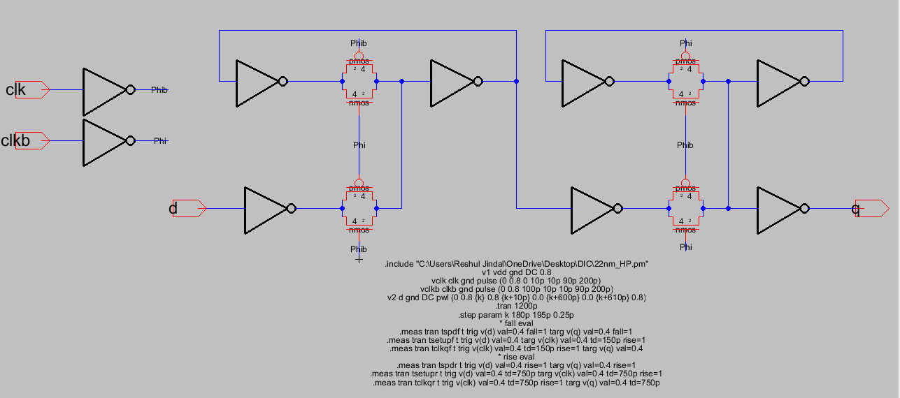

Waveforms and results

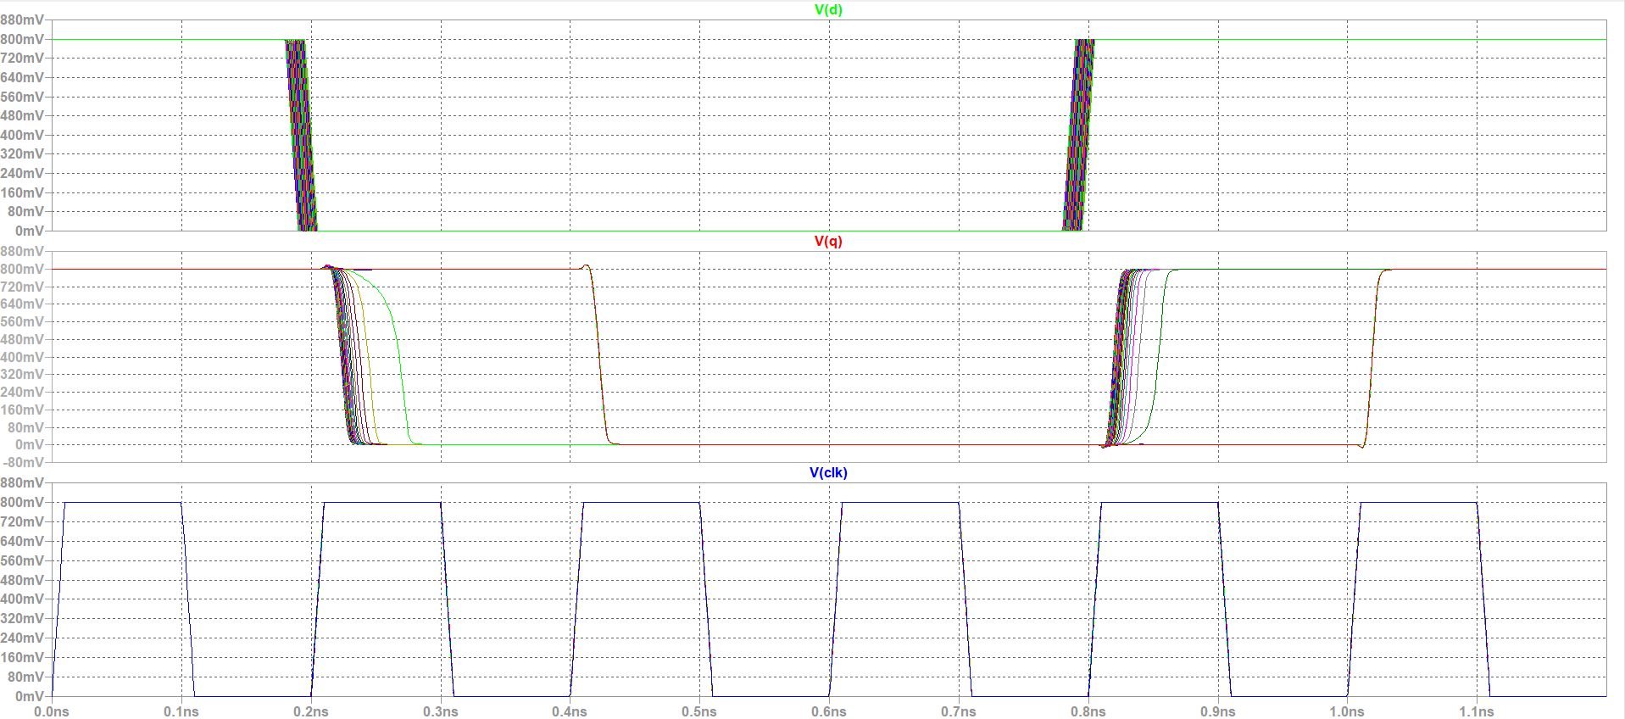

For Falling transition:

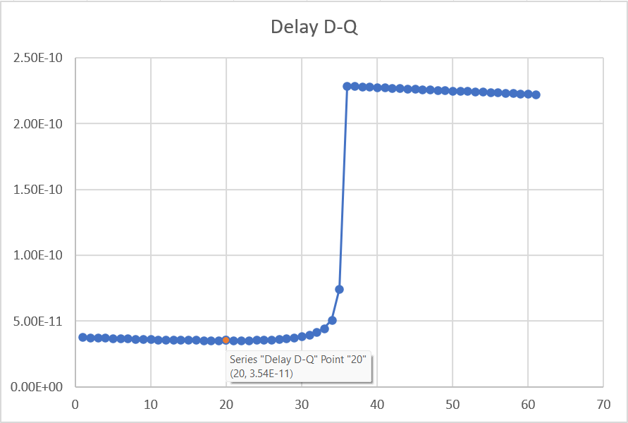

*The value of tsetup and tclk-q for the corresponding minimum point as per simulation results are:*

*tsetup = 15.25 ps*

*tclk-q = 20.1 ps*

For Rising Transition:

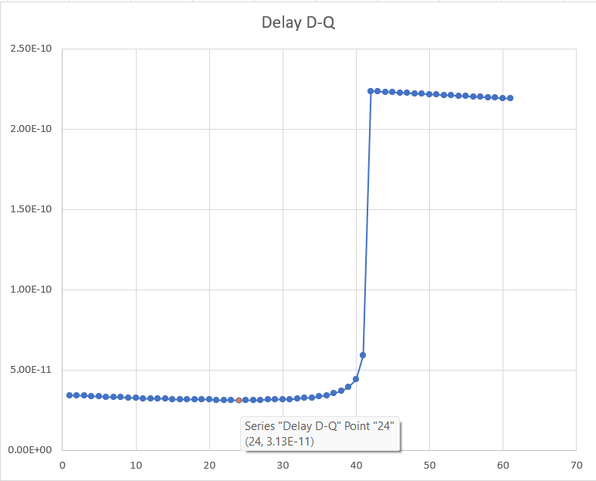

*The value of tsetup and tclk-q for the corresponding minimum point as per simulation results are:*

*tsetup = 14.25 ps*

*tclk-q = 17.095 ps*